TITLE should be less than 12 words, capitalized, centered, with Arial font size 14

Author¹, Author², Author³
Corresponding author’s e-mail address
Affiliation

Abstract
Abstract should not more than 300 words containing the importance of the topic, objective, method, findings, and conclusion. It should not contain any undefined abbreviations or unspecified references.

Keywords : keyword 1, keyword 2, keyword 3, keyword 4, keyword 5

Introduction
Articles submitted to the journal range between 4000-7000 words written in English in single space, using Microsoft Word, font size 11, Arial, top and left margin 3 cm, bottom and right margin 2.54 cm, printed in A4.
Introduction consists of the background of the study, research contexts, literary review (can be separated in different section), and research objective. All introduction should be presented in the forms of paragraphs, not pointers, with the proportion of 15-20% of the whole article length.

Method
This section consists of description concerning the research design, setting, participants, data sources, data collection, and data analysis with the proportion of 10-15% of the total article length, all presented in the form of paragraphs.

Findings and discussion
This section consists of description of the results of the data analysis to answer the research question(s) and their meanings seen from current theories and references of the area addressed. The proportion of this section is 40-60% of the total article length. In this section the author(s) may also provide some figures or tables to support the data display, for example :
Table 1 : (Title)

Source (if any)
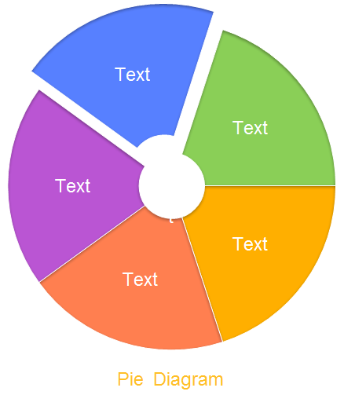

Figure 1 : (Title)
Source (if any)

Conclusion
This section consists of the summary, restatement, comment or evaluation of the main findings.

Reference
Quotation and reference follow APA 6th style and the latter should be included at the end of the article (highly recommended to use reference manager apps, e.g. Zotero, Mendeley). Every source cited in the body of the article should appear in this section, and all sources appearing in the reference should be cited in the body of the article. The sources cited should at least 80% come from those published in the last 10 years. The sources cited are primary sources in the forms of journal articles, books, and research reports, including theses and dissertations.

